**Scenario of Detach and Attach**

If I need to restore database but don't have a full backup, I can do it by adding mdf and ldf files. Detach and attach will be performed in this instance.

Three things to be noted:

1. Detach
2. Copy to another server
3. Attach

**Case 1: Detach and Attach Database using both mdf and ldf files**

Step 1: Open SQL Server then select one database and right click => Tasks => Detach.

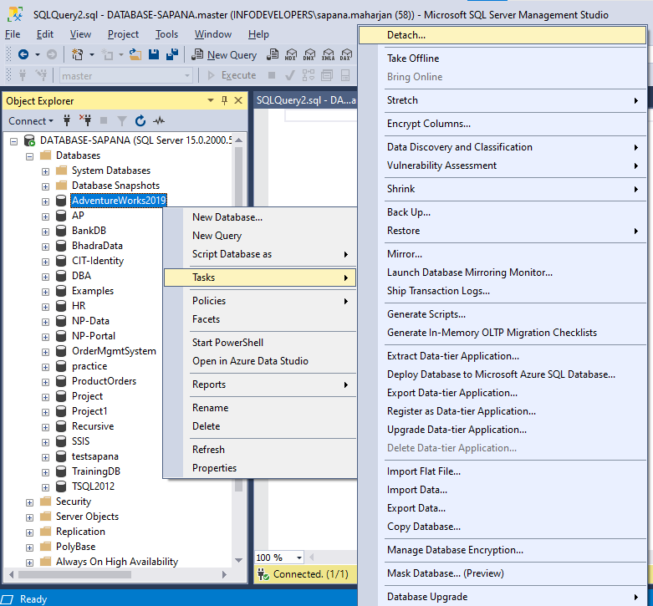

Step 2: Click ok to continue.

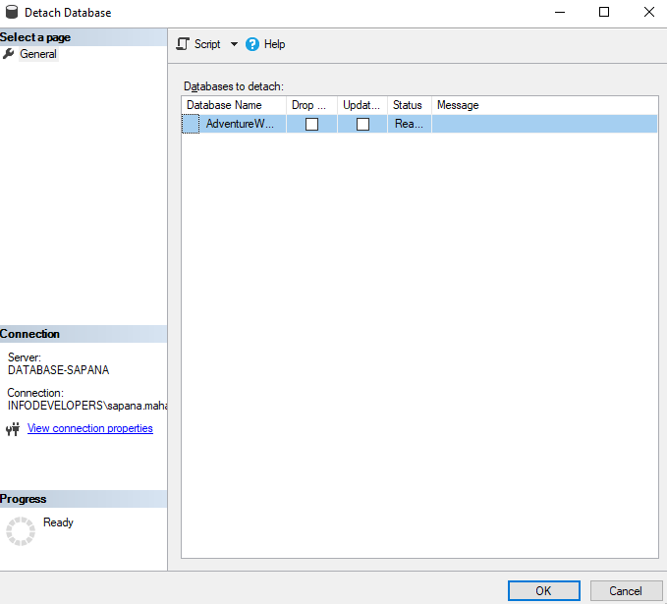

Step 3: Copy mdf and ldf file from ‘C:\Program Files\Microsoft SQL Server\MSSQL15.MSSQLSERVER\MSSQL\DATA’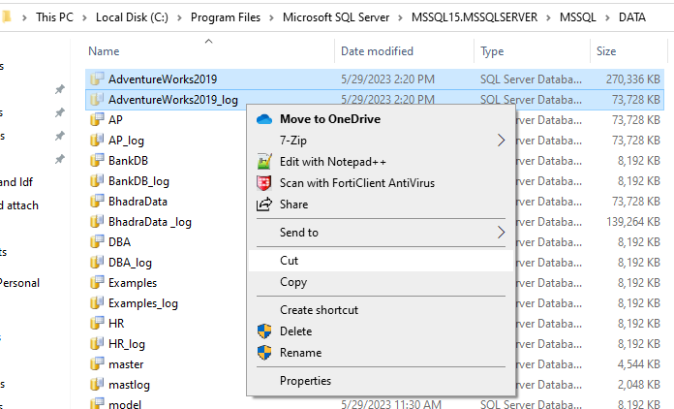

Step 4: And paste the file to ‘E:\att_det_db’

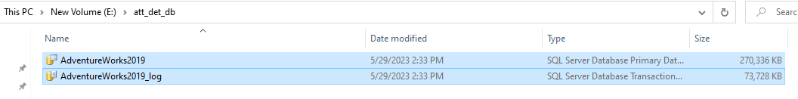

Step 5: Then right click to Databases => Attach

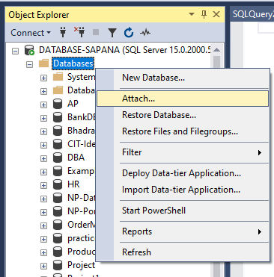

Step 6:

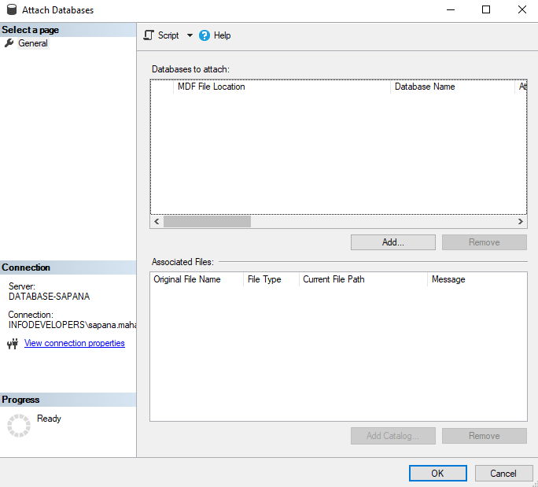

Click Add button to add ldf and mdf file from ‘E:\’



Click ok to continue

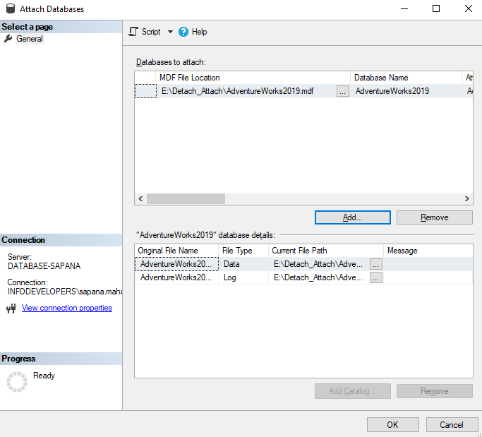

Click ok to continue then the database AdventureWorkd2019 will be restored.

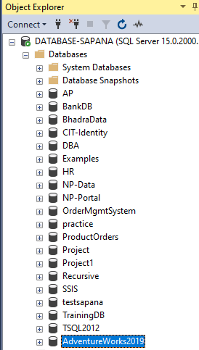

**Case 2: Detach and Attach Database using only mdf file**

Step 1: Open SQL Server then select database AdventureWorks2019 and right click => Tasks => Detach.

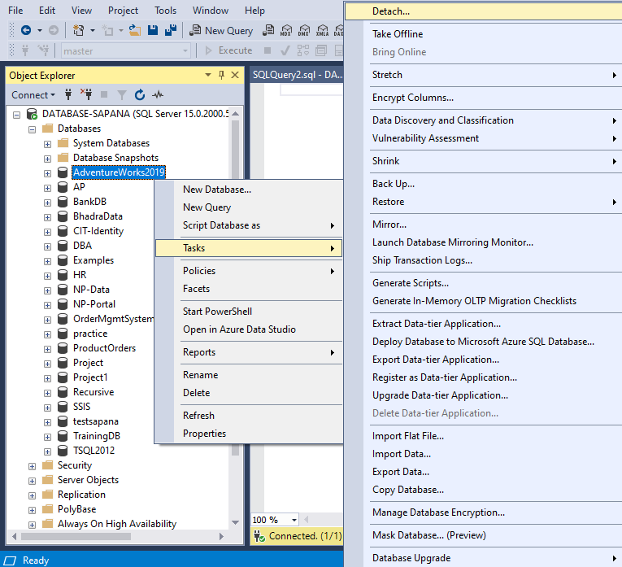

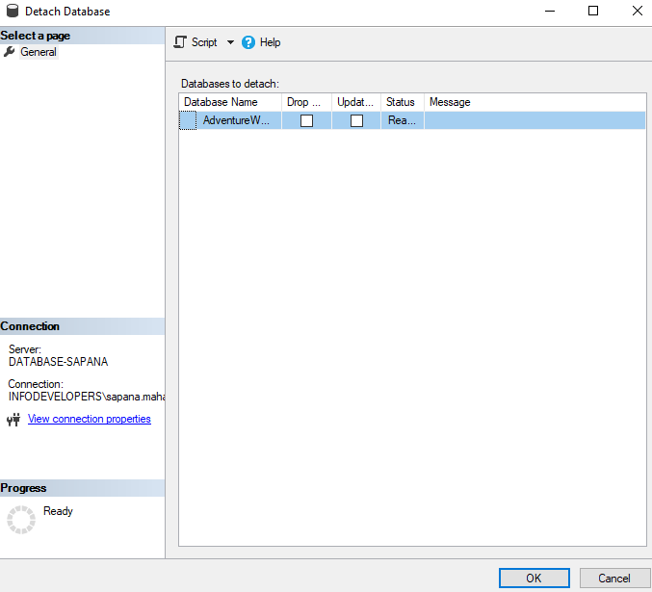

To proceed, press the OK button.

After that, database AdventureWorks2019 will be removed from the database.

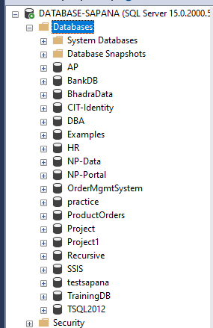

Delete AdventureWorks2019 ldf file from Detach_Attach_mdf folder.

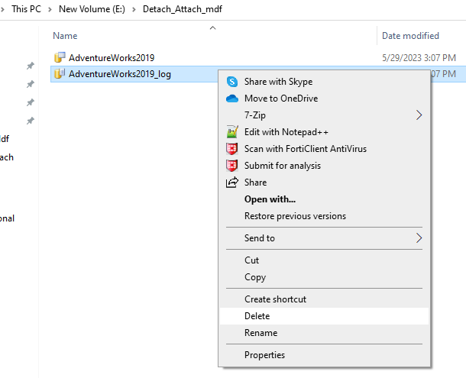



If I simply have the AdventureWorks2019 mdf file, I can access all of the data on another server.

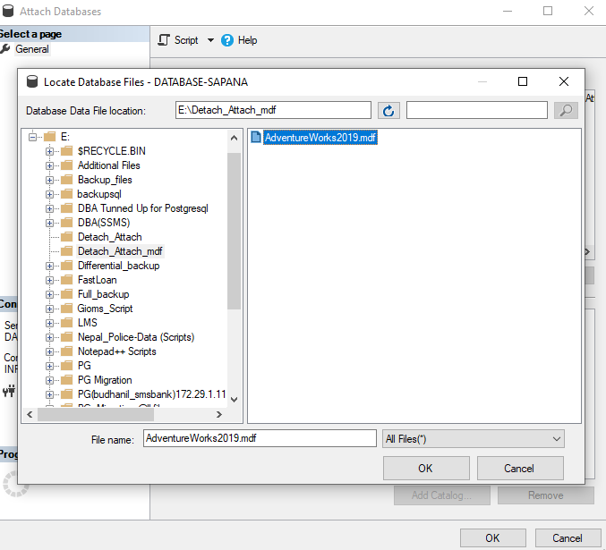

Click ok and then remove log (ldf) file.

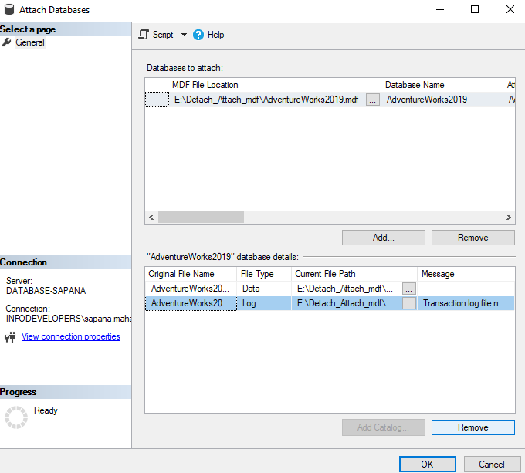

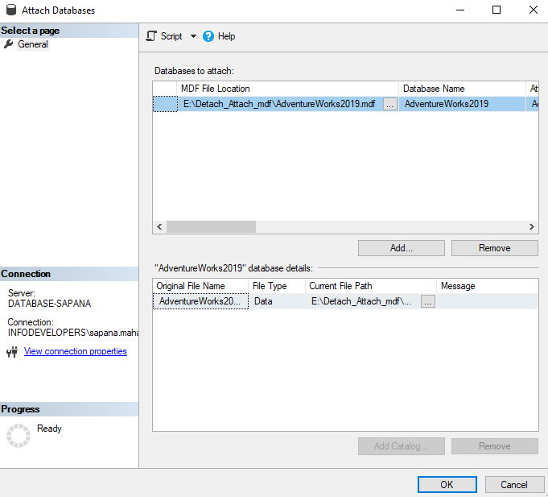

Click ok to continue.

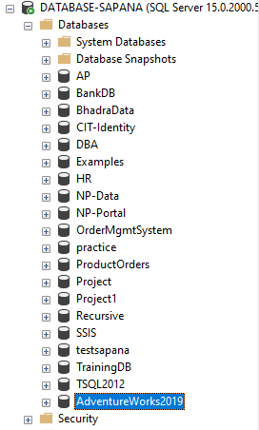

Here, database AdventureWorks2019 has been restored.

**Scenario of Detach and Attach Database by Stopping Service**

Three things to be noted:

1. Stop Service
2. Copy to another server
3. Attach the database

**Case 1: Detach and Attach Database from both mdf and ldf**

Step 1: Firstly, stop service

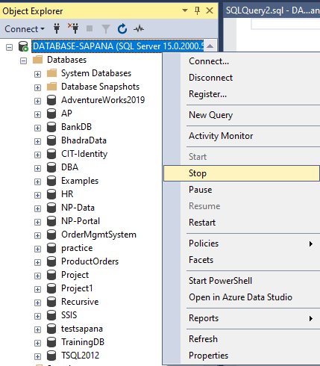

Click yes for confirming

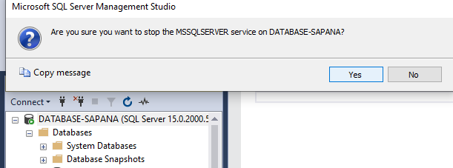

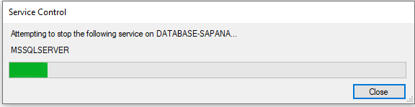

Step 2: Cut Detach_Attach_mdf folder from ‘E:\’

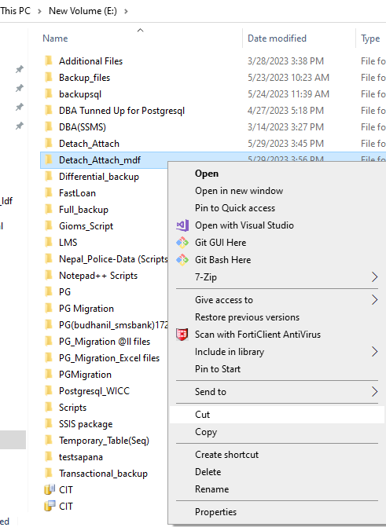

Paste that folder in ‘C:\’

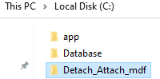

Step 3: Start service

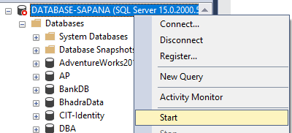

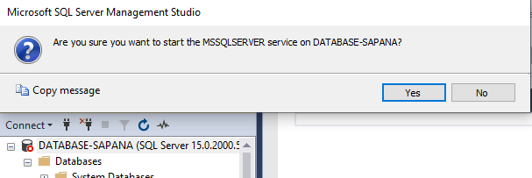

Click yes to continue

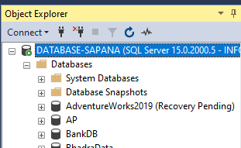

Then service will be started but AdventureWorks2019 is in Recovery Pending. So delete it.

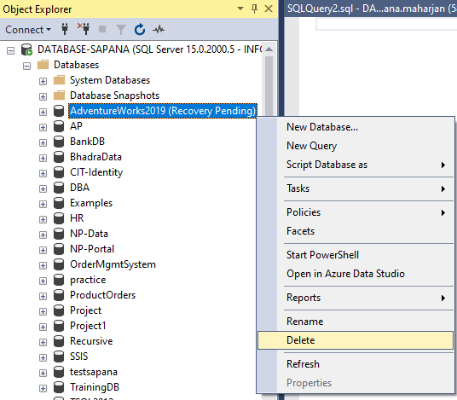

So, attach mdf and ldf file.

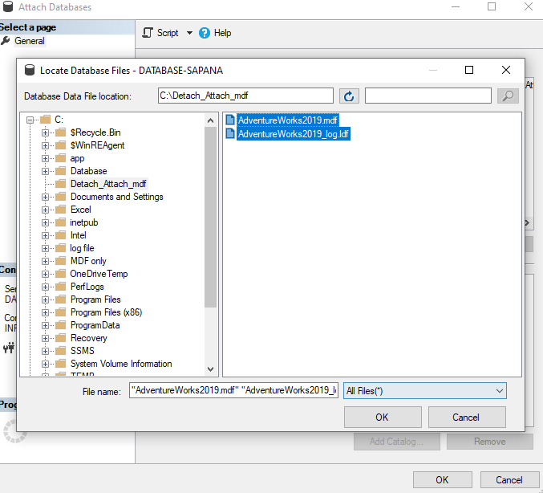

Click ok to continue then it will show error message

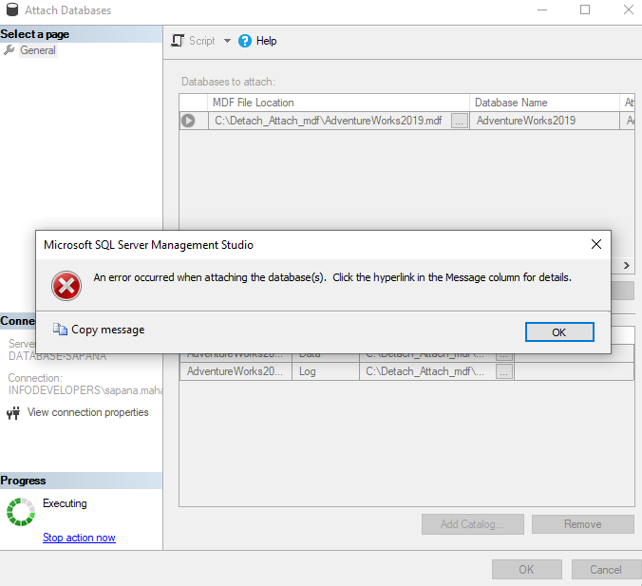

Select mdf file and go to properties

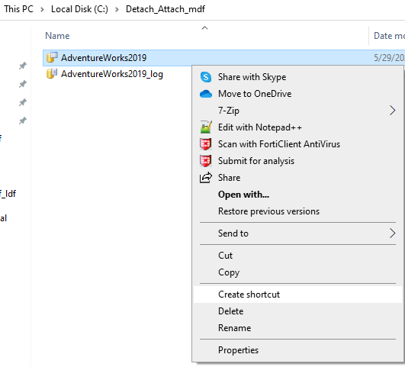

Give access full control to Users (DATABASE-SAPANA\Users)

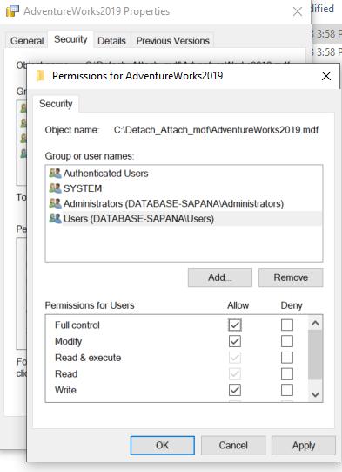

Select ldf file and go to properties

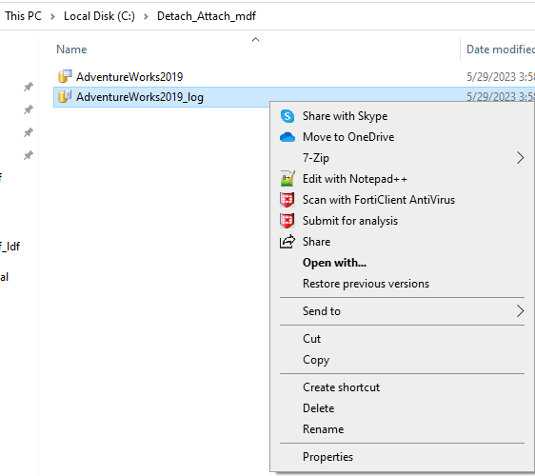

Give access full control to Users (DATABASE-SAPANA\Users).

Then click ok, database will be restored.

**Case 2: Detach and Attach Database using mdf file only**

Same case will be repeated.

